==========================================================

**Міністерство освіти і науки України**

**Національний технічний університет**

**«Дніпровська політехніка»**



**ЗВІТ**

**про виконання практичних робіт**

**Практична робота № 6,8**

Виконав:

студент гр. 124-19-2

Моторний Андрій Сергійович

Прийняв:

доцент кафедри системного аналізу і

управління.

**Алексєєв Олексій Михайлович**

**Дніпро**

**2020**

Звіт

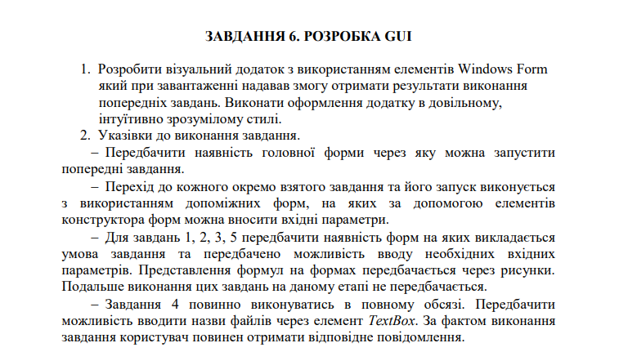

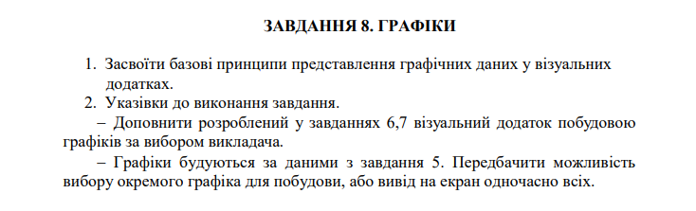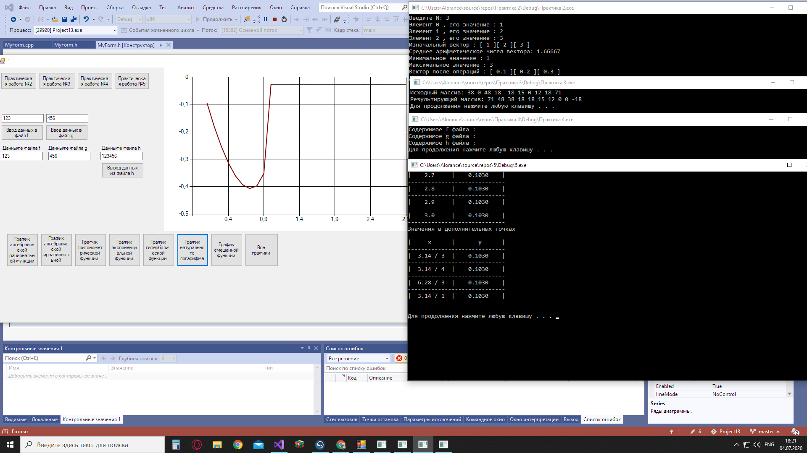

#pragma once

namespace Project13 {

using namespace System;

using namespace System::ComponentModel;

using namespace System::Collections;

using namespace System::Windows::Forms;

using namespace System::Data;

using namespace System::Drawing;

using namespace System::Diagnostics;

using namespace System::IO;

using namespace System::Windows::Forms::DataVisualization::Charting;

#include "math.h"

/// <summary>

/// Сводка для MyForm

/// </summary>

public ref class MyForm : public System::Windows::Forms::Form

{

public:

MyForm(void)

{

InitializeComponent();

//

//TODO: добавьте код конструктора

//

}

protected:

/// <summary>

/// Освободить все используемые ресурсы.

/// </summary>

~MyForm()

{

if (components)

{

delete components;

}

}

private: System::Windows::Forms::Button^ button1;

protected:

private: System::Windows::Forms::Button^ button2;

private: System::Windows::Forms::Button^ button3;

private: System::Windows::Forms::Button^ button4;

private: System::Windows::Forms::TextBox^ textBox1;

private: System::Windows::Forms::Button^ button5;

private: System::Windows::Forms::Button^ button6;

private: System::Windows::Forms::TextBox^ textBox2;

private: System::Windows::Forms::Button^ button7;

private: System::Windows::Forms::Label^ label1;

private: System::Windows::Forms::Label^ label2;

private: System::Windows::Forms::Label^ label3;

private: System::Windows::Forms::TextBox^ textBox3;

private: System::Windows::Forms::TextBox^ textBox4;

private: System::Windows::Forms::TextBox^ textBox5;

private: System::Windows::Forms::DataVisualization::Charting::Chart^ chart1;

private: System::Windows::Forms::Button^ button8;

private: System::Windows::Forms::Button^ button9;

private: System::Windows::Forms::Button^ button10;

private: System::Windows::Forms::Button^ button11;

private: System::Windows::Forms::Button^ button12;

private: System::Windows::Forms::Button^ button13;

private: System::Windows::Forms::Button^ button14;

private: System::Windows::Forms::Button^ button15;

private:

/// <summary>

/// Обязательная переменная конструктора.

/// </summary>

System::ComponentModel::Container ^components;

#pragma region Windows Form Designer generated code

/// <summary>

/// Требуемый метод для поддержки конструктора — не изменяйте

/// содержимое этого метода с помощью редактора кода.

/// </summary>

void InitializeComponent(void)

{

System::Windows::Forms::DataVisualization::Charting::ChartArea^ chartArea1 = (gcnew System::Windows::Forms::DataVisualization::Charting::ChartArea());

System::Windows::Forms::DataVisualization::Charting::Legend^ legend1 = (gcnew System::Windows::Forms::DataVisualization::Charting::Legend());

System::Windows::Forms::DataVisualization::Charting::Series^ series1 = (gcnew System::Windows::Forms::DataVisualization::Charting::Series());

this->button1 = (gcnew System::Windows::Forms::Button());

this->button2 = (gcnew System::Windows::Forms::Button());

this->button3 = (gcnew System::Windows::Forms::Button());

this->button4 = (gcnew System::Windows::Forms::Button());

this->textBox1 = (gcnew System::Windows::Forms::TextBox());

this->button5 = (gcnew System::Windows::Forms::Button());

this->button6 = (gcnew System::Windows::Forms::Button());

this->textBox2 = (gcnew System::Windows::Forms::TextBox());

this->button7 = (gcnew System::Windows::Forms::Button());

this->label1 = (gcnew System::Windows::Forms::Label());

this->label2 = (gcnew System::Windows::Forms::Label());

this->label3 = (gcnew System::Windows::Forms::Label());

this->textBox3 = (gcnew System::Windows::Forms::TextBox());

this->textBox4 = (gcnew System::Windows::Forms::TextBox());

this->textBox5 = (gcnew System::Windows::Forms::TextBox());

this->chart1 = (gcnew System::Windows::Forms::DataVisualization::Charting::Chart());

this->button8 = (gcnew System::Windows::Forms::Button());

this->button9 = (gcnew System::Windows::Forms::Button());

this->button10 = (gcnew System::Windows::Forms::Button());

this->button11 = (gcnew System::Windows::Forms::Button());

this->button12 = (gcnew System::Windows::Forms::Button());

this->button13 = (gcnew System::Windows::Forms::Button());

this->button14 = (gcnew System::Windows::Forms::Button());

this->button15 = (gcnew System::Windows::Forms::Button());

(cli::safe_cast<System::ComponentModel::ISupportInitialize^>(this->chart1))->BeginInit();

this->SuspendLayout();

//

// button1

//

this->button1->Location = System::Drawing::Point(13, 12);

this->button1->Name = L"button1";

this->button1->Size = System::Drawing::Size(85, 40);

this->button1->TabIndex = 0;

this->button1->Text = L"Практическая работа №2";

this->button1->UseVisualStyleBackColor = true;

this->button1->Click += gcnew System::EventHandler(this, &MyForm::Button1_Click);

//

// button2

//

this->button2->Location = System::Drawing::Point(104, 12);

this->button2->Name = L"button2";

this->button2->Size = System::Drawing::Size(85, 40);

this->button2->TabIndex = 1;

this->button2->Text = L"Практическая работа №3";

this->button2->UseVisualStyleBackColor = true;

this->button2->Click += gcnew System::EventHandler(this, &MyForm::Button2_Click);

//

// button3

//

this->button3->Location = System::Drawing::Point(195, 12);

this->button3->Name = L"button3";

this->button3->Size = System::Drawing::Size(84, 40);

this->button3->TabIndex = 2;

this->button3->Text = L"Практическая работа №4";

this->button3->UseVisualStyleBackColor = true;

this->button3->Click += gcnew System::EventHandler(this, &MyForm::Button3_Click);

//

// button4

//

this->button4->Location = System::Drawing::Point(285, 12);

this->button4->Name = L"button4";

this->button4->Size = System::Drawing::Size(81, 40);

this->button4->TabIndex = 3;

this->button4->Text = L"Практическая работа №5";

this->button4->UseVisualStyleBackColor = true;

this->button4->Click += gcnew System::EventHandler(this, &MyForm::Button4_Click);

//

// textBox1

//

this->textBox1->Location = System::Drawing::Point(15, 111);

this->textBox1->Name = L"textBox1";

this->textBox1->Size = System::Drawing::Size(100, 20);

this->textBox1->TabIndex = 4;

//

// button5

//

this->button5->Location = System::Drawing::Point(14, 137);

this->button5->Name = L"button5";

this->button5->Size = System::Drawing::Size(100, 36);

this->button5->TabIndex = 5;

this->button5->Text = L"Ввод данных в файл f";

this->button5->UseVisualStyleBackColor = true;

this->button5->Click += gcnew System::EventHandler(this, &MyForm::Button5_Click);

//

// button6

//

this->button6->Location = System::Drawing::Point(120, 137);

this->button6->Name = L"button6";

this->button6->Size = System::Drawing::Size(100, 36);

this->button6->TabIndex = 7;

this->button6->Text = L"Ввод данных в файл g";

this->button6->UseVisualStyleBackColor = true;

this->button6->Click += gcnew System::EventHandler(this, &MyForm::Button6_Click);

//

// textBox2

//

this->textBox2->Location = System::Drawing::Point(121, 111);

this->textBox2->Name = L"textBox2";

this->textBox2->Size = System::Drawing::Size(100, 20);

this->textBox2->TabIndex = 6;

//

// button7

//

this->button7->Location = System::Drawing::Point(253, 227);

this->button7->Name = L"button7";

this->button7->Size = System::Drawing::Size(100, 36);

this->button7->TabIndex = 9;

this->button7->Text = L"Вывод данных из файла h";

this->button7->UseVisualStyleBackColor = true;

this->button7->Click += gcnew System::EventHandler(this, &MyForm::Button7_Click);

//

// label1

//

this->label1->AutoSize = true;

this->label1->Location = System::Drawing::Point(14, 185);

this->label1->Name = L"label1";

this->label1->Size = System::Drawing::Size(97, 13);

this->label1->TabIndex = 13;

this->label1->Text = L"Данныфе файла f";

//

// label2

//

this->label2->AutoSize = true;

this->label2->Location = System::Drawing::Point(123, 185);

this->label2->Name = L"label2";

this->label2->Size = System::Drawing::Size(100, 13);

this->label2->TabIndex = 14;

this->label2->Text = L"Данныфе файла g";

//

// label3

//

this->label3->AutoSize = true;

this->label3->Location = System::Drawing::Point(250, 185);

this->label3->Name = L"label3";

this->label3->Size = System::Drawing::Size(100, 13);

this->label3->TabIndex = 15;

this->label3->Text = L"Данныфе файла h";

//

// textBox3

//

this->textBox3->Location = System::Drawing::Point(13, 201);

this->textBox3->Name = L"textBox3";

this->textBox3->Size = System::Drawing::Size(100, 20);

this->textBox3->TabIndex = 16;

//

// textBox4

//

this->textBox4->Location = System::Drawing::Point(126, 201);

this->textBox4->Name = L"textBox4";

this->textBox4->Size = System::Drawing::Size(100, 20);

this->textBox4->TabIndex = 17;

//

// textBox5

//

this->textBox5->Location = System::Drawing::Point(250, 201);

this->textBox5->Name = L"textBox5";

this->textBox5->Size = System::Drawing::Size(100, 20);

this->textBox5->TabIndex = 18;

//

// chart1

//

chartArea1->Name = L"ChartArea1";

this->chart1->ChartAreas->Add(chartArea1);

legend1->Name = L"Legend1";

this->chart1->Legends->Add(legend1);

this->chart1->Location = System::Drawing::Point(402, 0);

this->chart1->Name = L"chart1";

this->chart1->Palette = System::Windows::Forms::DataVisualization::Charting::ChartColorPalette::Excel;

series1->BorderWidth = 2;

series1->ChartArea = L"ChartArea1";

series1->ChartType = System::Windows::Forms::DataVisualization::Charting::SeriesChartType::Line;

series1->Color = System::Drawing::Color::Maroon;

series1->EmptyPointStyle->Color = System::Drawing::Color::Black;

series1->EmptyPointStyle->LabelBackColor = System::Drawing::Color::White;

series1->LabelForeColor = System::Drawing::Color::Transparent;

series1->Legend = L"Legend1";

series1->MarkerBorderColor = System::Drawing::Color::Transparent;

series1->Name = L"Series1";

series1->ShadowColor = System::Drawing::Color::Gray;

series1->YValuesPerPoint = 2;

this->chart1->Series->Add(series1);

this->chart1->Size = System::Drawing::Size(724, 390);

this->chart1->TabIndex = 19;

this->chart1->Text = L"chart1";

//

// button8

//

this->button8->Location = System::Drawing::Point(27, 396);

this->button8->Name = L"button8";

this->button8->Size = System::Drawing::Size(75, 78);

this->button8->TabIndex = 20;

this->button8->Text = L"График алгебраической рациональной функции";

this->button8->UseVisualStyleBackColor = true;

this->button8->Click += gcnew System::EventHandler(this, &MyForm::Button8_Click);

//

// button9

//

this->button9->Location = System::Drawing::Point(108, 396);

this->button9->Name = L"button9";

this->button9->Size = System::Drawing::Size(75, 78);

this->button9->TabIndex = 21;

this->button9->Text = L"График алгебраической иррациональной функции";

this->button9->UseVisualStyleBackColor = true;

this->button9->Click += gcnew System::EventHandler(this, &MyForm::Button9_Click);

//

// button10

//

this->button10->Location = System::Drawing::Point(189, 396);

this->button10->Name = L"button10";

this->button10->Size = System::Drawing::Size(75, 78);

this->button10->TabIndex = 22;

this->button10->Text = L"График тригонометрической функции ";

this->button10->UseVisualStyleBackColor = true;

this->button10->Click += gcnew System::EventHandler(this, &MyForm::Button10_Click);

//

// button11

//

this->button11->Location = System::Drawing::Point(270, 396);

this->button11->Name = L"button11";

this->button11->Size = System::Drawing::Size(75, 78);

this->button11->TabIndex = 23;

this->button11->Text = L"График экспоненциальной функции";

this->button11->UseVisualStyleBackColor = true;

this->button11->Click += gcnew System::EventHandler(this, &MyForm::Button11_Click);

//

// button12

//

this->button12->Location = System::Drawing::Point(351, 396);

this->button12->Name = L"button12";

this->button12->Size = System::Drawing::Size(75, 78);

this->button12->TabIndex = 24;

this->button12->Text = L"График гиперболической функции ";

this->button12->UseVisualStyleBackColor = true;

this->button12->Click += gcnew System::EventHandler(this, &MyForm::Button12_Click);

//

// button13

//

this->button13->Location = System::Drawing::Point(432, 396);

this->button13->Name = L"button13";

this->button13->Size = System::Drawing::Size(75, 78);

this->button13->TabIndex = 25;

this->button13->Text = L"График натурального логарифма";

this->button13->UseVisualStyleBackColor = true;

this->button13->Click += gcnew System::EventHandler(this, &MyForm::Button13_Click);

//

// button14

//

this->button14->Location = System::Drawing::Point(513, 396);

this->button14->Name = L"button14";

this->button14->Size = System::Drawing::Size(75, 78);

this->button14->TabIndex = 26;

this->button14->Text = L"График смешанной функции";

this->button14->UseVisualStyleBackColor = true;

this->button14->Click += gcnew System::EventHandler(this, &MyForm::Button14_Click);

//

// button15

//

this->button15->Location = System::Drawing::Point(594, 396);

this->button15->Name = L"button15";

this->button15->Size = System::Drawing::Size(79, 78);

this->button15->TabIndex = 27;

this->button15->Text = L"Все графики";

this->button15->UseVisualStyleBackColor = true;

this->button15->Click += gcnew System::EventHandler(this, &MyForm::Button15_Click);

//

// MyForm

//

this->AutoScaleDimensions = System::Drawing::SizeF(6, 13);

this->AutoScaleMode = System::Windows::Forms::AutoScaleMode::Font;

this->ClientSize = System::Drawing::Size(1138, 608);

this->Controls->Add(this->button15);

this->Controls->Add(this->button14);

this->Controls->Add(this->button13);

this->Controls->Add(this->button12);

this->Controls->Add(this->button11);

this->Controls->Add(this->button10);

this->Controls->Add(this->button9);

this->Controls->Add(this->button8);

this->Controls->Add(this->chart1);

this->Controls->Add(this->textBox5);

this->Controls->Add(this->textBox4);

this->Controls->Add(this->textBox3);

this->Controls->Add(this->label3);

this->Controls->Add(this->label2);

this->Controls->Add(this->label1);

this->Controls->Add(this->button7);

this->Controls->Add(this->button6);

this->Controls->Add(this->textBox2);

this->Controls->Add(this->button5);

this->Controls->Add(this->textBox1);

this->Controls->Add(this->button4);

this->Controls->Add(this->button3);

this->Controls->Add(this->button2);

this->Controls->Add(this->button1);

this->Name = L"MyForm";

this->Text = L"`";

(cli::safe_cast<System::ComponentModel::ISupportInitialize^>(this->chart1))->EndInit();

this->ResumeLayout(false);

this->PerformLayout();

}

#pragma endregion

private: System::Void Button1_Click(System::Object^ sender, System::EventArgs^ e)

{

Process::Start("C:\\Users\\Alorance\\source\\repos\\Практика 2\\Debug\\Практика 2.exe");

}

private: System::Void BackgroundWorker1_DoWork(System::Object^ sender, System::ComponentModel::DoWorkEventArgs^ e) {

}

private: System::Void Button2_Click(System::Object^ sender, System::EventArgs^ e)

{

Process::Start("C:\\Users\\Alorance\\source\\repos\\Практика 3\\Debug\\Практика 3.exe");

}

private: System::Void Button3_Click(System::Object^ sender, System::EventArgs^ e)

{

Process::Start("C:\\Users\\Alorance\\source\\repos\\Практика 4\\Debug\\Практика 4.exe");

}

private: System::Void Button4_Click(System::Object^ sender, System::EventArgs^ e)

{

Process::Start("C:\\Users\\Alorance\\source\\repos\\5\\Debug\\5.exe");

}

private: System::Void Button5_Click(System::Object^ sender, System::EventArgs^ e)

{

StreamWriter^ sw = gcnew StreamWriter("C:\\Users\\Alorance\\Desktop\\1\\f.txt"); "\n", "\r";

sw->WriteLine(textBox1->Text);

sw->Close();

System::IO::StreamReader^ sr = gcnew System::IO::StreamReader("C:\\Users\\Alorance\\Desktop\\1\\f.txt");

System::String^ text = sr->ReadToEnd();

textBox3->Text = text;

sr->Close();

}

private: System::Void Button6_Click(System::Object^ sender, System::EventArgs^ e)

{

StreamWriter^ sw = gcnew StreamWriter("C:\\Users\\Alorance\\Desktop\\1\\g.txt"); "\n", "\r";

sw->WriteLine(textBox2->Text);

sw->Close();

System::IO::StreamReader^ sr = gcnew System::IO::StreamReader("C:\\Users\\Alorance\\Desktop\\1\\g.txt");

System::String^ text = sr->ReadToEnd();

textBox4->Text = text;

sr->Close();

}

private: System::Void Button7_Click(System::Object^ sender, System::EventArgs^ e)

{

StreamWriter^ sw = gcnew StreamWriter("C:\\Users\\Alorance\\Desktop\\1\\h.txt"); "\n", "\r";

sw->WriteLine(textBox3->Text);

sw->WriteLine(textBox4->Text);

sw->Close();

System::IO::StreamReader^ sr = gcnew System::IO::StreamReader("C:\\Users\\Alorance\\Desktop\\1\\h.txt");

System::String^ text = sr->ReadToEnd();

textBox5->Text = text;

sr->Close();

}

private: System::Void Button8_Click(System::Object^ sender, System::EventArgs^ e)

{

double x, xn=0, xk=3, xh=0.1;

Series^ plot1 = chart1->Series[0];

plot1->Points->Clear();

x = xn;

while (x <= xk)

{

plot1->Points->AddXY(x, 1 / pow((1 - pow(x, 2)), 3));

x = x + xh;

}

}

private: System::Void Button9_Click(System::Object^ sender, System::EventArgs^ e)

{

double x, xn = 0, xk = 3, xh = 0.1;

Series^ plot1 = chart1->Series[0];

plot1->Points->Clear();

x = xn;

while (x <= xk)

{

plot1->Points->AddXY(x, sqrt(1 + pow(x, 2)) / (pow(x, 2) * sqrt(x)));

x = x + xh;

}

}

private: System::Void Button10_Click(System::Object^ sender, System::EventArgs^ e)

{

double x, xn = 0, xk = 3, xh = 0.1;

Series^ plot1 = chart1->Series[0];

plot1->Points->Clear();

x = xn;

while (x <= xk)

{

plot1->Points->AddXY(x, 1 / (pow(sqrt(1 - pow(sin(x), 3)), 4)));

x = x + xh;

}

}

private: System::Void Button11_Click(System::Object^ sender, System::EventArgs^ e)

{

double x, xn = 0, xk = 3, xh = 0.1;

Series^ plot1 = chart1->Series[0];

plot1->Points->Clear();

x = xn;

while (x <= xk)

{

plot1->Points->AddXY(x, 1 / (pow(exp(x), -x) * (1 - pow(x, 2))));

x = x + xh;

}

}

private: System::Void Button12_Click(System::Object^ sender, System::EventArgs^ e)

{

double x, xn = 0, xk = 3, xh = 0.1;

Series^ plot1 = chart1->Series[0];

plot1->Points->Clear();

x = xn;

while (x <= xk)

{

plot1->Points->AddXY(x, 1 / pow(cosh(x) + 1, 2));

x = x + xh;

}

}

private: System::Void Button13_Click(System::Object^ sender, System::EventArgs^ e)

{

double x, xn = 0, xk = 3, xh = 0.1;

Series^ plot1 = chart1->Series[0];

plot1->Points->Clear();

x = xn;

while (x <= xk)

{

plot1->Points->AddXY(x, pow(x, 2) / log(1 - x));

x = x + xh;

}

}

private: System::Void Button14_Click(System::Object^ sender, System::EventArgs^ e)

{

double x, xn = 0, xk = 3, xh = 0.1;

Series^ plot1 = chart1->Series[0];

double Gr2 = 3.2360679775;

double Gr4 = 6.472135955;

plot1->Points->Clear();

x = xn;

while (x <= xk)

{

plot1->Points->AddXY(x, 1 / (Gr2 + Gr4));

x = x + xh;

}

}

private: System::Void Button15_Click(System::Object^ sender, System::EventArgs^ e)

{

double x, xn = 0, xk = 3, xh = 0.1;

Series^ plot1 = chart1->Series[0];

double Gr2 = 3.2360679775;

double Gr4 = 6.472135955;

plot1->Points->Clear();

x = xn;

while (x <= xk)

{

plot1->Points->AddXY(x, 1 / (Gr2 + Gr4));

plot1->Points->AddXY(x, pow(x, 2) / log(1 - x));

plot1->Points->AddXY(x, 1 / pow(cosh(x) + 1, 2));

plot1->Points->AddXY(x, 1 / (pow(exp(x), -x) * (1 - pow(x, 2))));

plot1->Points->AddXY(x, 1 / (pow(sqrt(1 - pow(sin(x), 3)), 4)));

plot1->Points->AddXY(x, 1 / pow((1 - pow(x, 2)), 3));

plot1->Points->AddXY(x, sqrt(1 + pow(x, 2)) / (pow(x, 2) * sqrt(x)));

x = x + xh;

}

}

};

}